Forest vs. Trees
Your goal in this assignment is to find, and present, any recurring cohesive elements the author uses to unify separate elements into one work. Some examples of possible recurring elements include patterns, comparisons, contrasts, and incongruities.
You will be required to portray your analysis in a creative manner. Here are some suggestions.
Low-tech
- Analyze the way the author uses recurring elements to effectively convey his or her message
- written/spoken analysis supported by visuals
- form=function. Attempt to duplicate/emphasize/recreate/model the author’s use in your own presentation (i.e. if the author uses contrast, including juxtaposed visual elements to represent her use of contrast)
- You might consider making, but are not limited to, a publication such as a magazine/book/brochure, a poster, a 3D model, an original work of music, a series of letters, a first-person diary in which you assume the persona of an author, and many other suggestions which you make..
Hi-tech
- Analyze the way the author uses recurring elements to effectively convey his or her message
- analysis presented in and supported by a mix of various electronic media
- form=function. Attempt to duplicate/emphasize/recreate/model the author’s use in your own presentation (i.e. if the author uses contrast, including juxtaposed visual elements to represent her use of contrast)
- You might consider making, but are not limited to, a video interview with the “author”, a prezi, a video parody, animation, a website, a music video, and many other things that might be the product of creative planning.
Essay
What this lacks in creativity will be made up for in sheer depth. Write a 4-5 page essay that analyzes the way the author uses recurring elements to effectively convey his or her message. Typed, MLA, double-spaced, academic, well-developed, strong analysis.

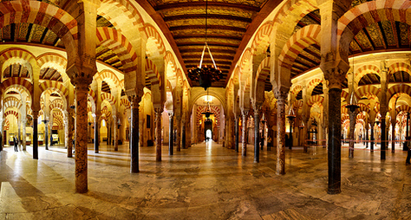
Remember: this is a MAJOR GRADE. Your work should reflect this. The high-tech/low-tech options are presented as an alternative to a longer essay. Your work needs to reflect creative and/or thorough planning, an honest engagement with the work, and attention to detail and content.

